V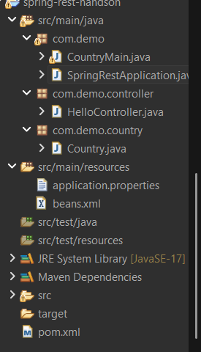

package com.demo;

import org.springframework.boot.SpringApplication;
import org.springframework.boot.autoconfigure.SpringBootApplication;

@SpringBootApplication
public class SpringRestApplication {

public static void main(String[] args) {
SpringApplication.run(SpringRestApplication.class, args);
}
}

package com.demo.controller;

import org.springframework.web.bind.annotation.GetMapping;
import org.springframework.web.bind.annotation.RestController;

@RestController
public class HelloController {

@GetMapping("/hello")
public String hello() {
return "Hello World REST Service";
}
}
. ____ _ __ _ _
/\\ / ___'_ __ _ _(_)_ __ __ _ \ \ \ \
( ( )\___ | '_ | '_| | '_ \/ _` | \ \ \ \
\\/ ___)| |_)| | | | | || (_| | ) ) ) )
' |____| .__|_| |_|_| |_\__, | / / / /
=========|_|==============|___/=/_/_/_/
:: Spring Boot :: (v3.2.0)

2026-07-01T14:30:19.540+05:30 INFO 30176 --- [ main] com.demo.SpringRestApplication : Starting SpringRestApplication using Java 21.0.9 with PID 30176 (D:\spring-rest-handson\target\classes started by akshy in D:\spring-rest-handson)
2026-07-01T14:30:19.550+05:30 INFO 30176 --- [ main] com.demo.SpringRestApplication : No active profile set, falling back to 1 default profile: "default"
2026-07-01T14:30:22.810+05:30 INFO 30176 --- [ main] o.s.b.w.embedded.tomcat.TomcatWebServer : Tomcat initialized with port 8082 (http)
2026-07-01T14:30:22.842+05:30 INFO 30176 --- [ main] o.apache.catalina.core.StandardService : Starting service [Tomcat]
2026-07-01T14:30:22.843+05:30 INFO 30176 --- [ main] o.apache.catalina.core.StandardEngine : Starting Servlet engine: [Apache Tomcat/10.1.16]
2026-07-01T14:30:23.030+05:30 INFO 30176 --- [ main] o.a.c.c.C.[Tomcat].[localhost].[/] : Initializing Spring embedded WebApplicationContext
2026-07-01T14:30:23.033+05:30 INFO 30176 --- [ main] w.s.c.ServletWebServerApplicationContext : Root WebApplicationContext: initialization completed in 3244 ms
2026-07-01T14:30:24.426+05:30 INFO 30176 --- [ main] o.s.b.w.embedded.tomcat.TomcatWebServer : Tomcat started on port 8082 (http) with context path ''
2026-07-01T14:30:24.453+05:30 INFO 30176 --- [ main] com.demo.SpringRestApplication : Started SpringRestApplication in 6.384 seconds (process running for 8.071)
2026-07-01T14:30:57.701+05:30 INFO 30176 --- [nio-8082-exec-1] o.a.c.c.C.[Tomcat].[localhost].[/] : Initializing Spring DispatcherServlet 'dispatcherServlet'
2026-07-01T14:30:57.701+05:30 INFO 30176 --- [nio-8082-exec-1] o.s.web.servlet.DispatcherServlet : Initializing Servlet 'dispatcherServlet'
2026-07-01T14:30:57.704+05:30 INFO 30176 --- [nio-8082-exec-1] o.s.web.servlet.DispatcherServlet : Completed initialization in 1 ms

OUTPUT:
